Monthly School newsletter

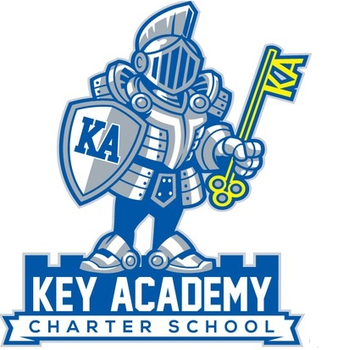

Newsletter October

Volume 1, Issue 2

u

Join us on October 10, 2013 at Chuck E. Cheese; 24039 Hesperian Blvd. Hayward, CA 94545. We will be there from 5-9 pm. A portion of the proceeds will be given back to KEY Academy. The money raised that night will be used to buy PE/Recess equipment for our students. We will also be fundraising to buy our teachers LCD monitors/projectors to use in the classroom.

We are trying to put together a recess soccer team for our 2nd-8th grade students. If any parents are interested in helping coach our two soccer teams, 2nd-3rd grade team and our 4th-8th grade team during lunch, please come to the office and let us know! We would like to have a match with Faith Ringgold at the end of the month.

# Recess Soccer

# Chuck E Cheese



Thank you for your patience as we come up with the best solution for dismissal time. We are trying to alleviate some of the traffic congestion that is building up on Ward and Sixth Street and dismiss our students as quickly and safely as possible.

One of the issues we are having is parents coming to the School before 3:15 pm. Faith Ringgold is dismissed at 3:00 pm, Monday, Tuesday, Thursday, and Friday. We need to give them time to pick up their students and leave the school area. In addition, they have two school busses that need to be able to come into the parking area and pick up students. We are asking our parents, not to come into the pick-up line until **3:20 pm**. This will allow for Faith Ringgold’s parents to pick-up their children and the busses to get through the traffic quickly and be on time for their next location

Please remind your student to look for their cars and be ready to leave in the afternoon. We have also been reminding students to be in their car groups. If possible, please have your child enter the car on the right side to avoid going into traffic. Also, when exiting from the school, please make a right turn onto D Street to help with the flow of traffic.

Remember to park on the streets if you are coming onto the school grounds to pick up your student. There are limited parking spaces on campus and we cannot allow parents to park in the pick-up line and leave their cars to get students. Also, please be aware of the street signs. Some streets do not allow any parking and Hayward City Police Department will be regularly checking for cars parked in no parking zones. Finally, we want everyone to be safe, so please obey all pedestrian and traffic rules.

# Dismissal Time

The hot lunch program has begun! We are working with Hayward Unified School District to help provide a quality and nutritious lunch for our students.

Menus will be made available on the website and will be sent home weekly. Please return the menu with your lunch selections and the amount owed on Monday mornings to your classroom teacher.

We are also working with Hayward Unified on providing lunch numbers for our students. Once we have student lunch numbers, parents can add money to their student’s accounts and not have to send money weekly.

Lastly, we are working on getting our free and reduced lunch application approved. Until then, all lunches are $2.50. Cash or checks will be accepted. Checks can now be made out to Hayward Unified School District.

# Hot Lunch

**Assembly**

Wednesday, October 16

**Chuck E. Cheese’s Fundraiser**

Wednesday, October 10th (5pm-9pm)

**Fall Break**

Monday, October 14th & Tuesday, October 15th

**Parent Committee**

Wednesday, October 23, 6:00 P.M.

**Tentative Soccer Game with Faith Ringgold**

Thursday, October 31

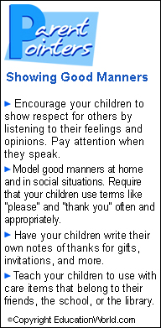

Chocolate and Stickers are still on sale in the office! Bring back the money to office after you have sold the items.



Remember to return all forms (Emergency, picture release, & income survey) into the office!

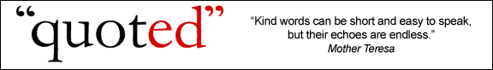

# Parent’s Corner

# Character Counts



Here are some fun tips you can use to help your child succeed.

**Parent Committee**

If you are interested in helping the school fundraise and organize school events, please join us on Wednesday, October 23rd to continue our discussion on supporting the School. We will be meeting in Ms. Tiffani’s classroom at 6:00 pm.

[](http://www.google.com/imgres?q=remind&um=1&hl=en&rlz=1R2ADRA_enUS422&biw=1280&bih=733&tbm=isch&tbnid=SfgePQqkGphG-M:&imgrefurl=http://dzspeakingenglish.blogspot.com/2010/05/tip-remember-vs-remind.html&docid=SNnwgYoeSmt5LM&w=306&h=303&ei=qYthTrOiBMHmiALT8t29Dg&zoom=1)

## Upcoming Events

We continue to work on the character trait, respect this month. To celebrate our accomplishments and what we have learned, we will be having our assembly on Wednesday, October 16th to celebrate being respectful.

Our first grade class will be presenting some of the things they have learned about respect to all of us and help us get started with our next character trait, responsibility. We look forward to seeing what they have planned!

**KEY Academy School Newsletter Page 2**